Performance Counters

# Performance Counter

http://www.pluralsight.com/courses/application-instrumentation-using-performance-counters

### Performance Counter Organization

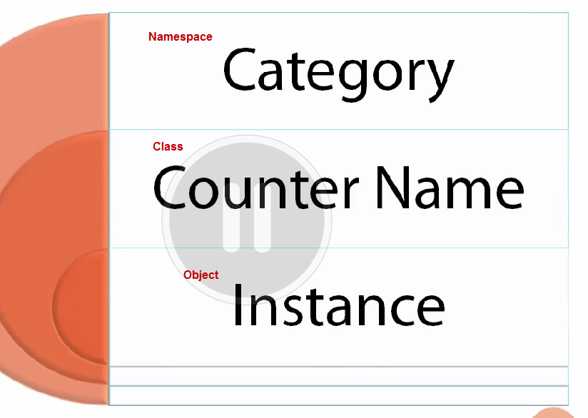

### Counter Path

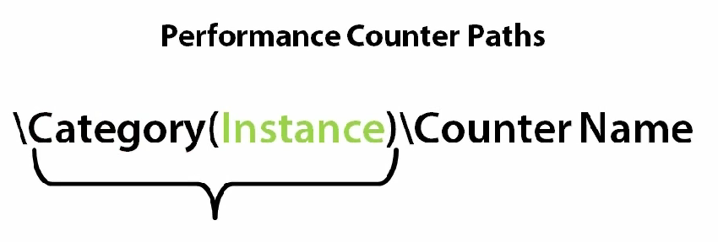







### Demo——get-counter

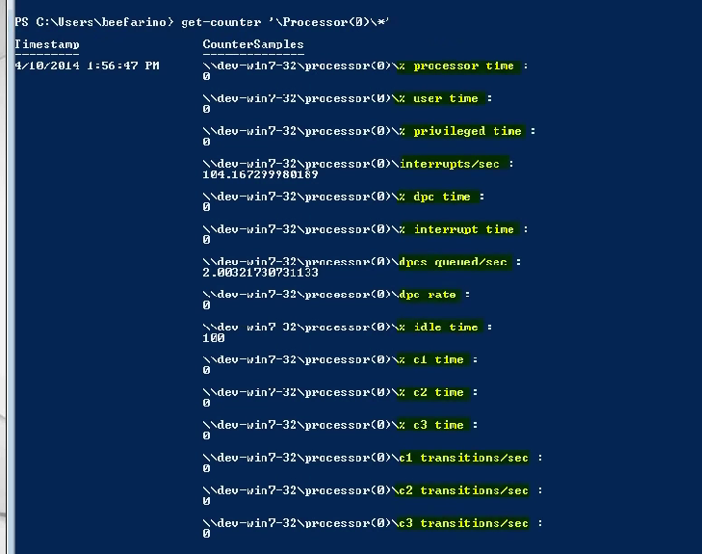



### Performance Counter Lifecycyle

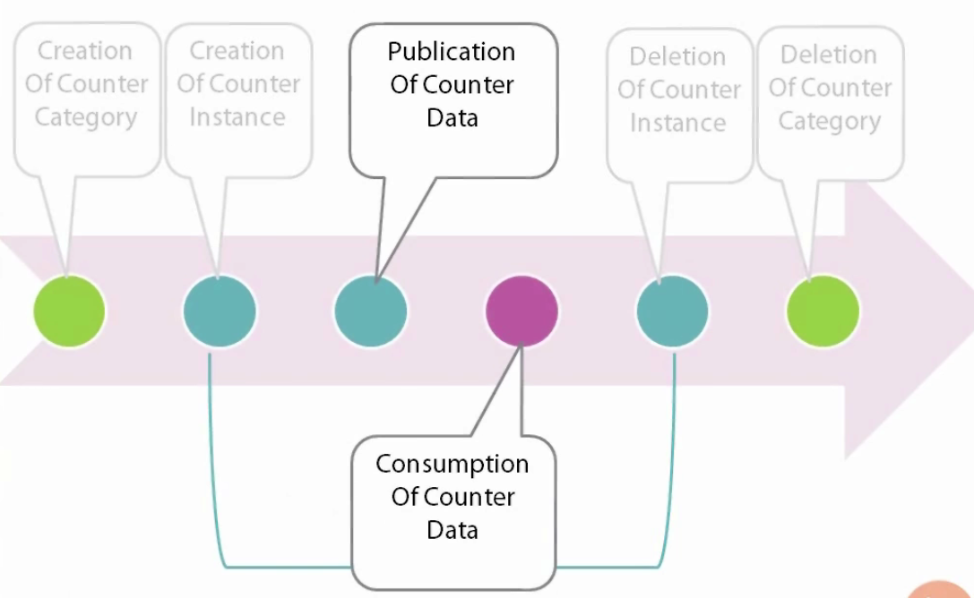

# Performance Counter

### 分类

* 1. 获取Counter的最新值（绝对值）
  2. 获取历史值的差值（变化值）
  3. 获取平均值
  4. 获取比率、百分比

### Value Types

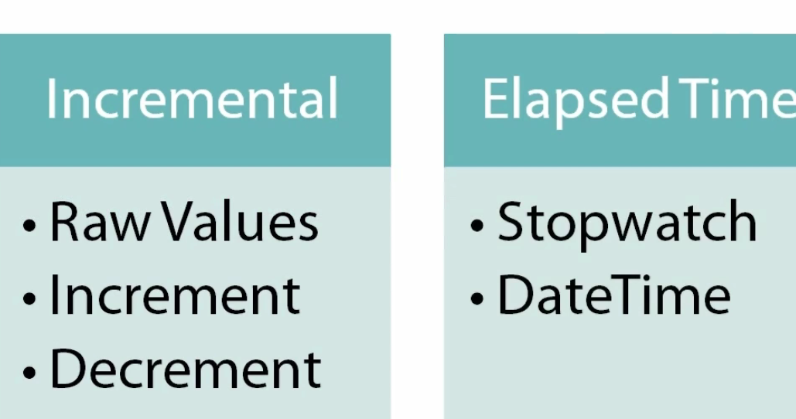

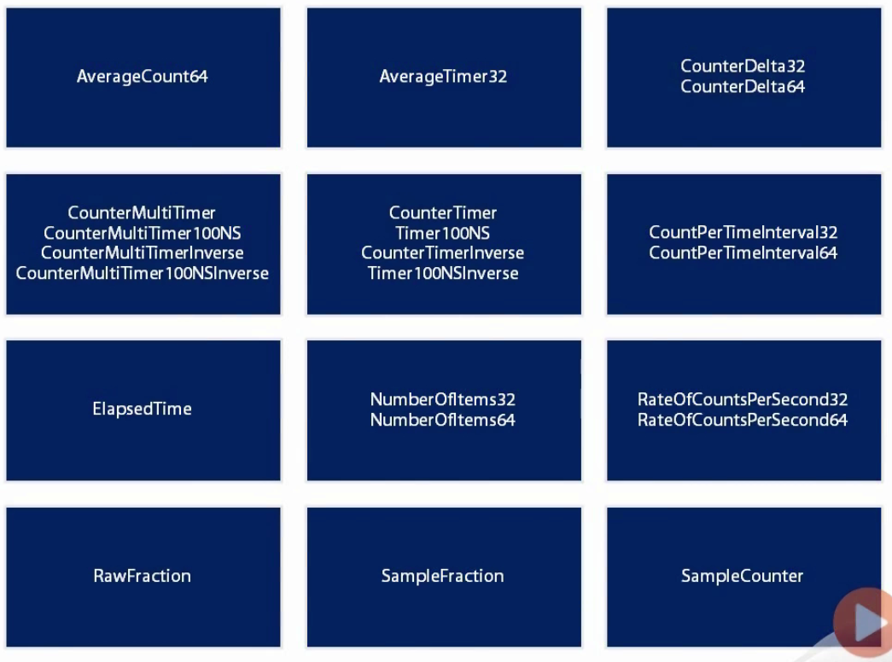

# Custom Performance Counter

### Key Pounding Performance Counter

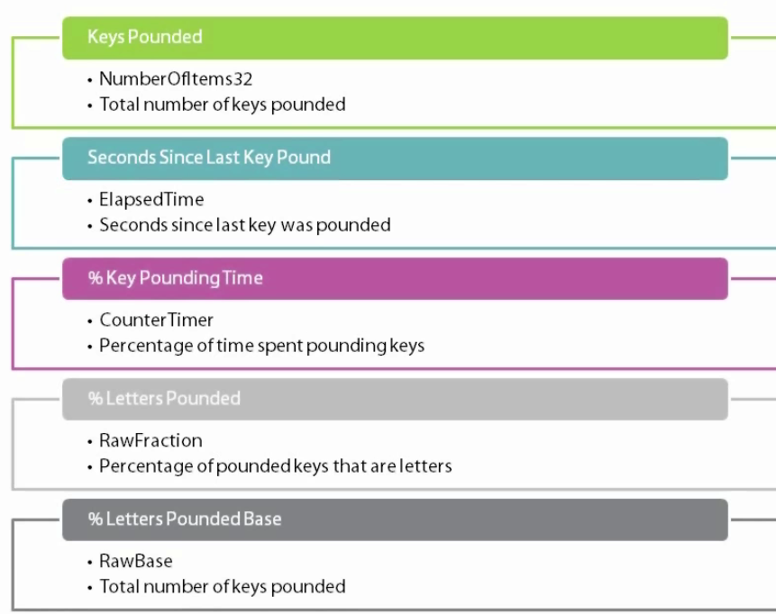

### Manage with Code

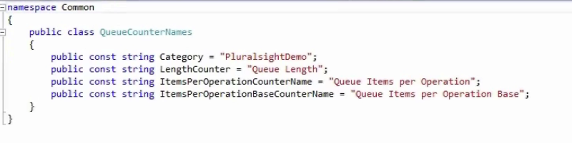

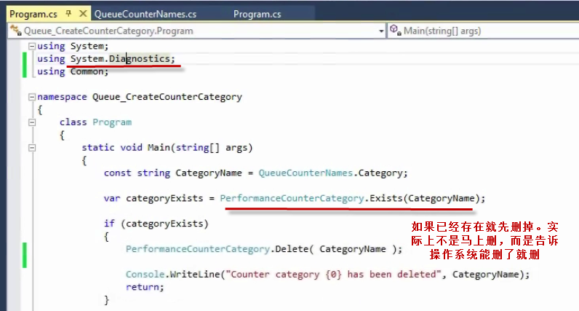

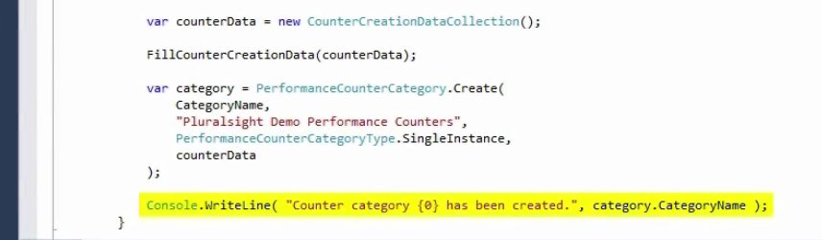

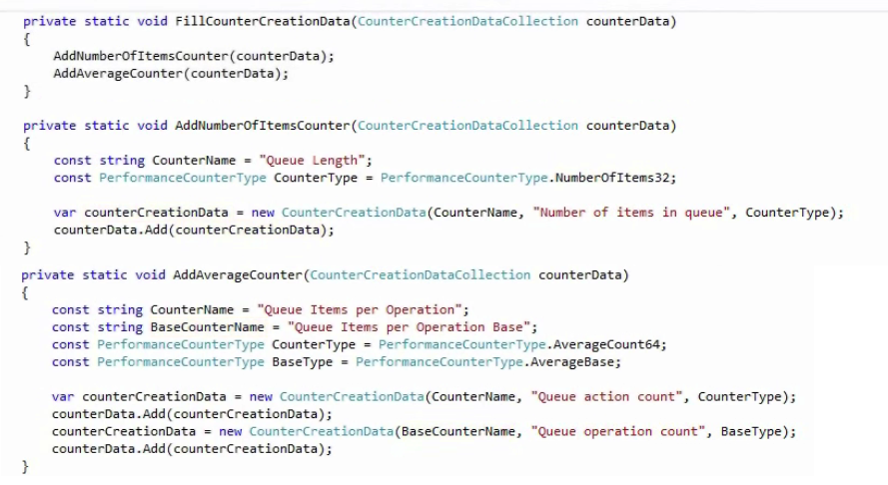

### Windows Installer ——WIX



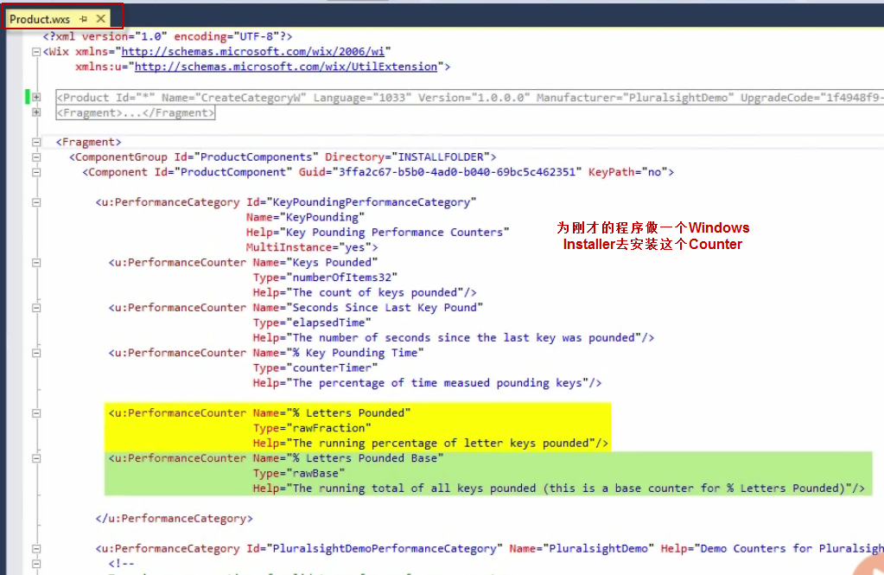

Debug了之后就出现了installer

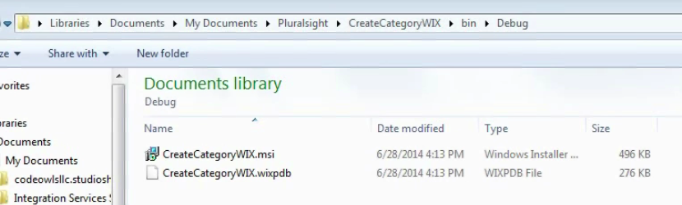

### Single Instance Counter

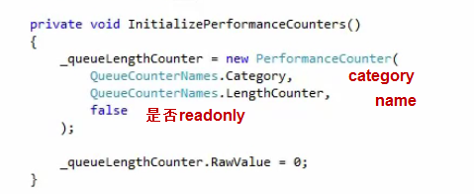

### Multi Instance Counter

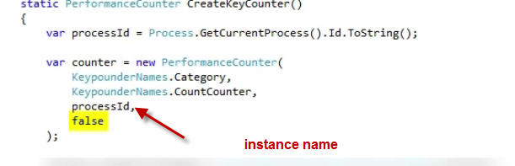

### Composite Counter

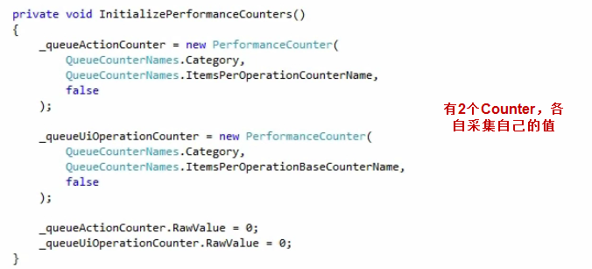

### Increment a Counter

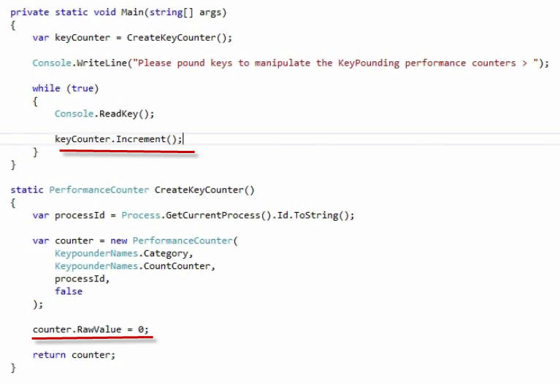

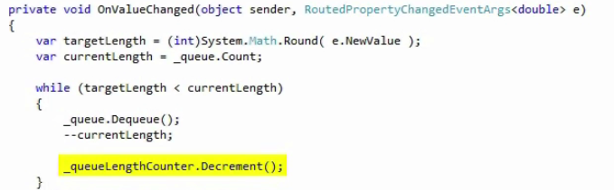

### Change Counter by value

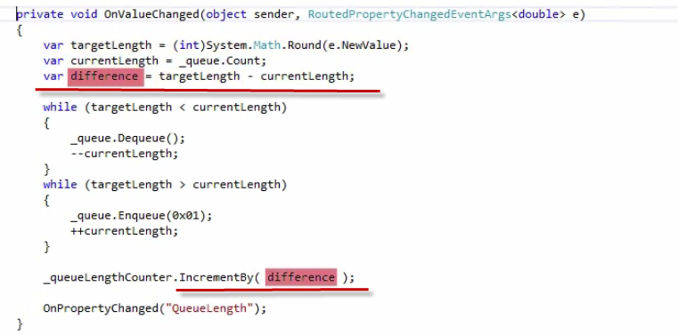

### Publish Composite Counter

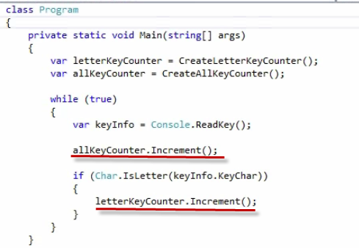

### Elapsed Time Measurements

